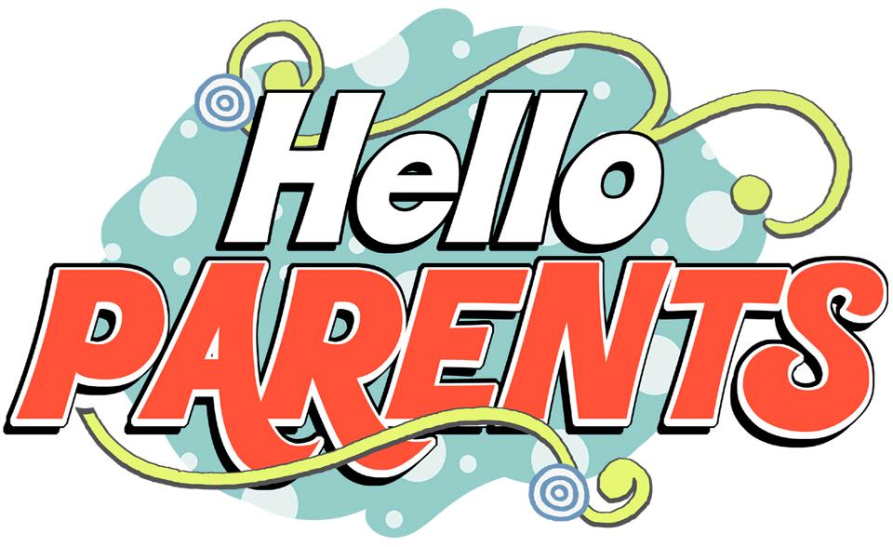  - ESE Parent Connector News  Resources for Families    MAKE YOUR VOICE HEARD!  wwwesesurvey.com  HELP IMPROVE EDUCATIONAL SERVICES FOR STUDENTS WITH SPECIAL NEEDS.  The Florida Department of Education surveys parent of students with disabilities in Exceptional Student Education (ESE). The survey helps our district meet the needs of both families and students.    https://familycafe.net/  MARK YOUR CALENDARS: Conference  The 24th Annual Family Cafe’, May 27-29, 2022  Hyatt Regency Orlando, Florida  - Free registration for Families and persons with Disabilities  - A Governors Summit  - Trainings  - Specialty Vendors  - Networking Opportunities  - Family Friendly Fun | INFORMATION  & EVENTS  & EVENTSwww.pcsb.org/Page/849  https://  www.pcsb.org/Page/849Page/849https://www.pcsb.org/Page/849 https://www.pcsb.org/Page/849  ____  Need more help? Ask your child’s ESE Teacher/Case Manager  ____  Have Ideas/Questions?  Contact:  ____  School Name  Phone Number  ESE Parent Connector Name  Pinellas County Schools  eXCEPTIONAL sTUDENT eDUCATION  301 4TH Street S.W.  Largo, Florida 33779  727-588-6062  https://www.pcsb.org/ese  Spring 2022

